LAB2 

1. Create a user account with the following attribute
   * username: islam
   * Fullname/comment: Islam Askar
   * Password: islam

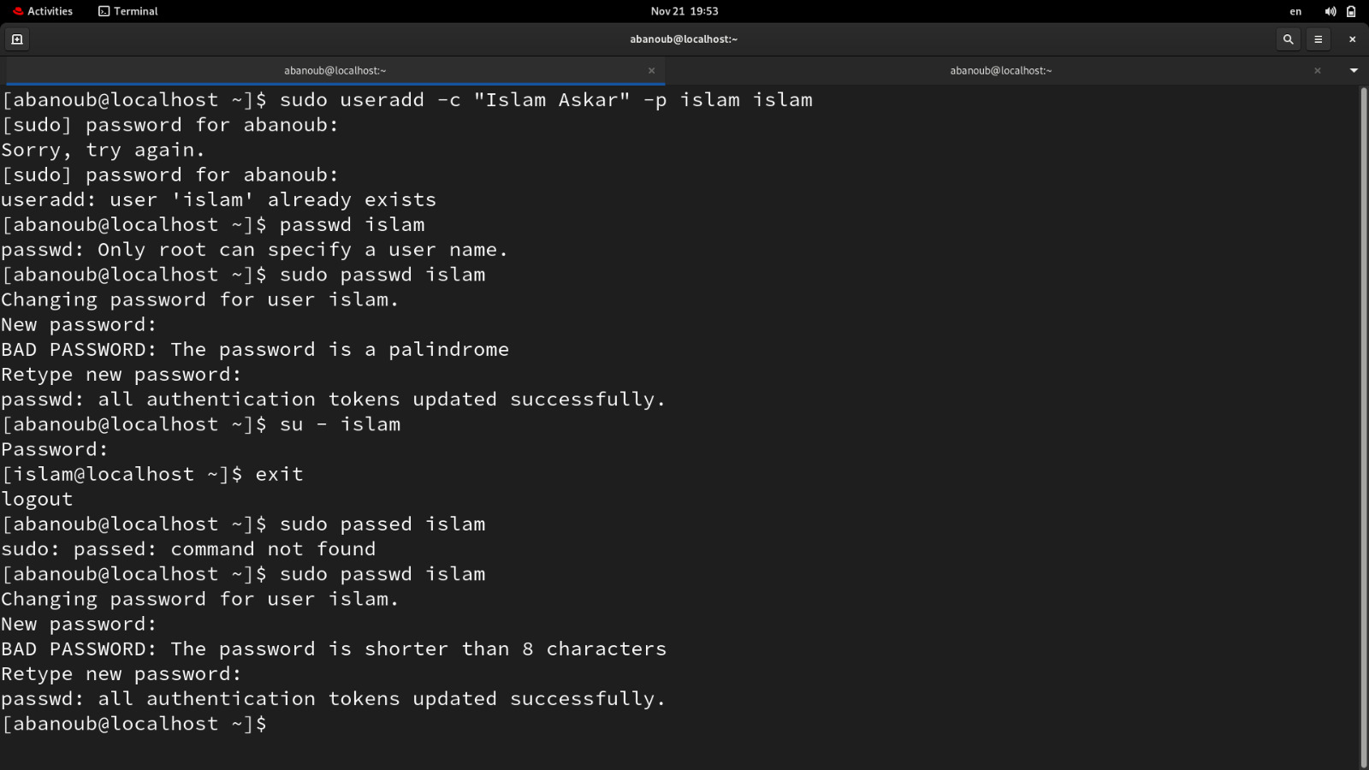

1. Create a user account with the following attribute
   * Username: baduser
   * Full name/comment: Bad User
   * Password: baduser

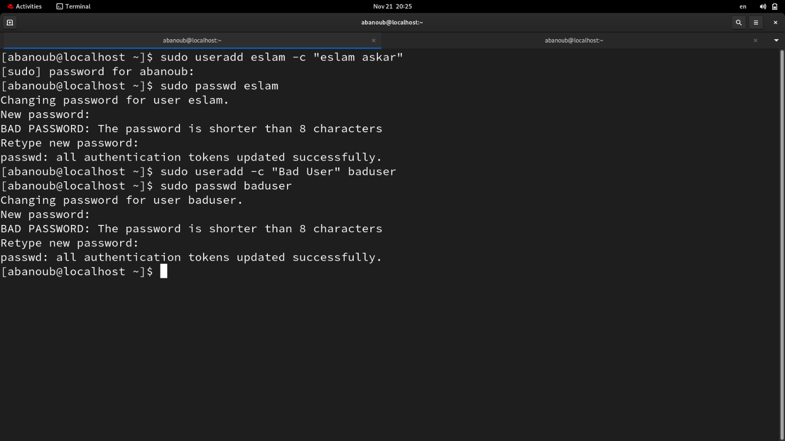

1. Create a supplementary (Secondary) group called pgroup with group ID of 30000
2. Create a supplementary group called badgroup
3. Add islam user to the pgroup group as a supplementary group
4. Modify the password of islam's account to *password*

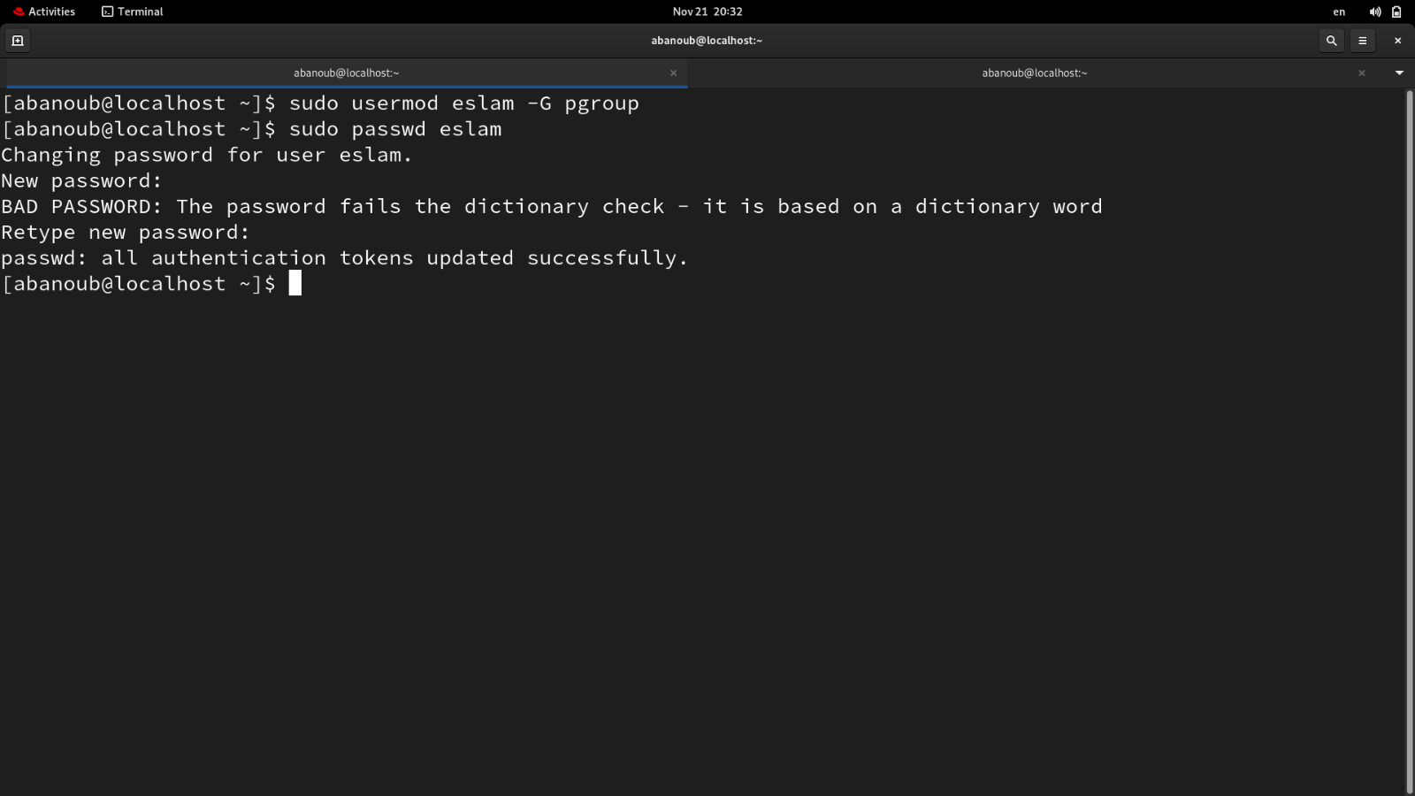

1. Modify islam's account so the password expires after 30 days

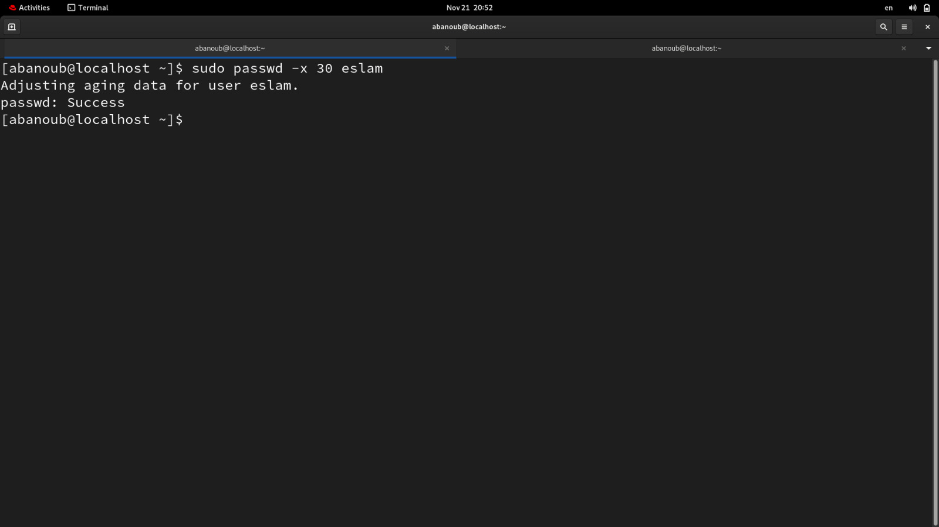

1. Lock bad user account so he can't log in
2. Delete bad user account
3. Delete the supplementary group called badgroup.

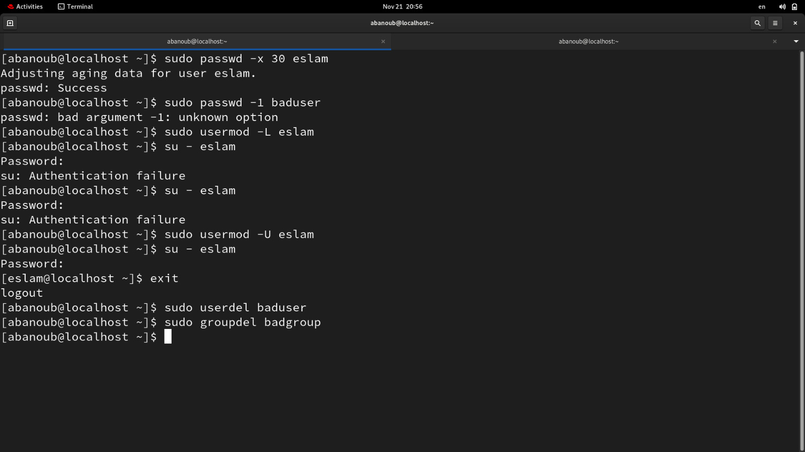

1. 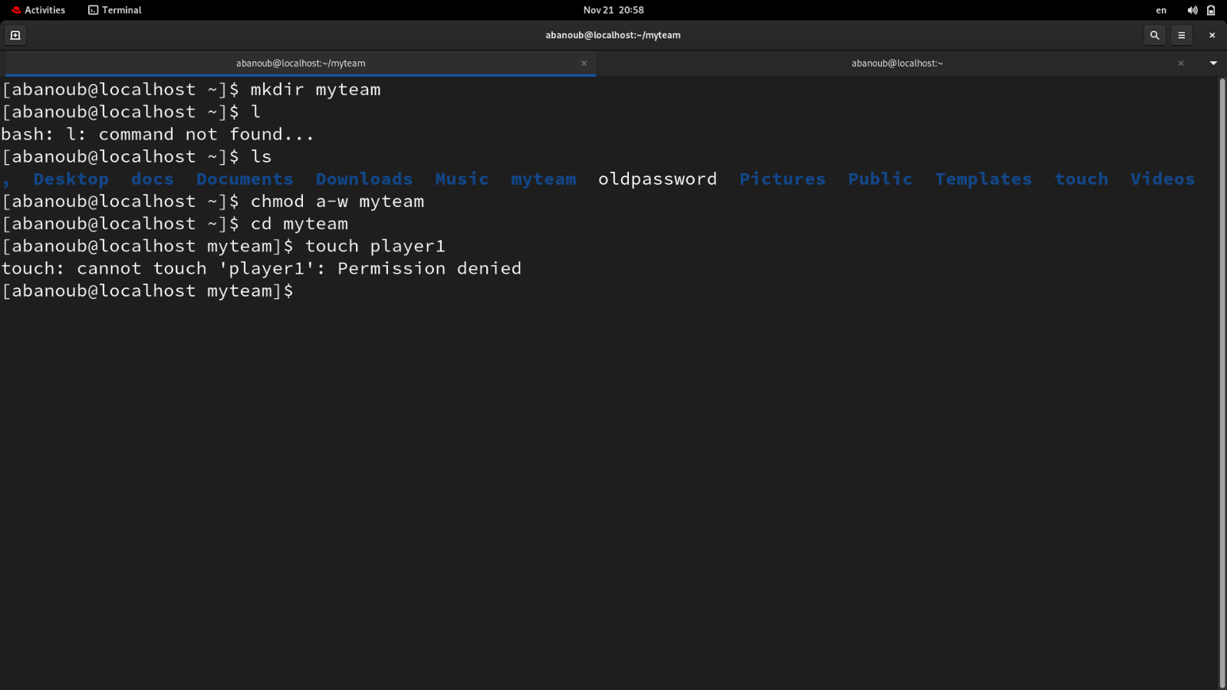Create a folder called myteam in your home directory and change its permissions to read only for the owner.
2. Log out and log in by another user

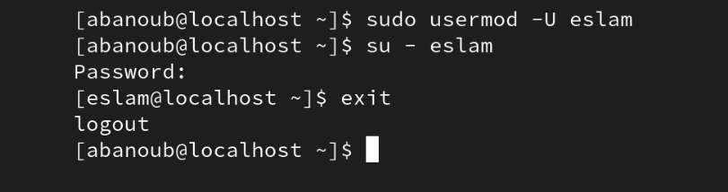

1. Try to access (by cd command) the folder (myteam)

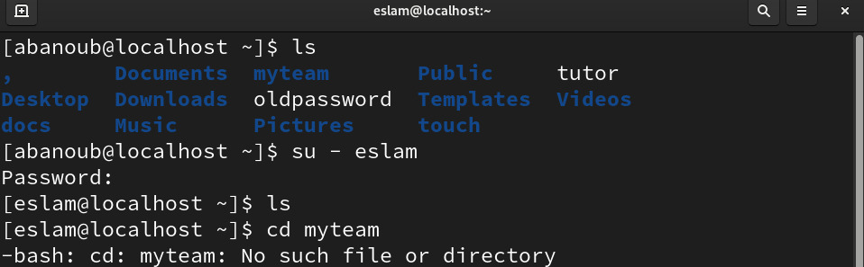

1. Using the command Line
   * Change the permissions of oldpasswd file to give owner read and write permissions and for group write and execute and execute only for the others (using chmod in 2 different ways)
   * Change your default permissions to be as above.

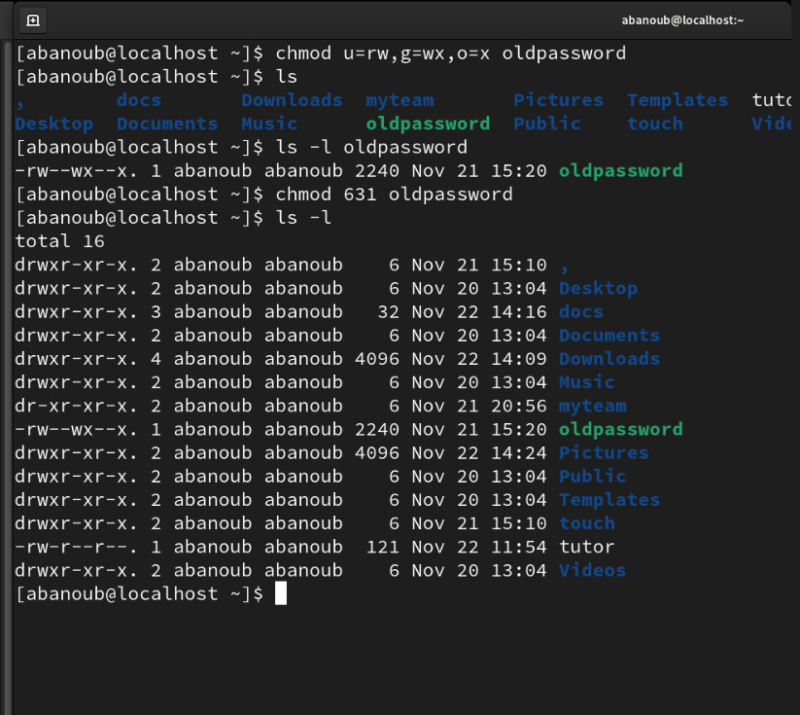

* + What is the maximum permission a file can have, by default when it is just created? And what is that for directory.

**File : 6 permissions**

**Directory : 9 permissions**

* + Change your default permissions to be no permission to everyone then create a directory and a file to verify.

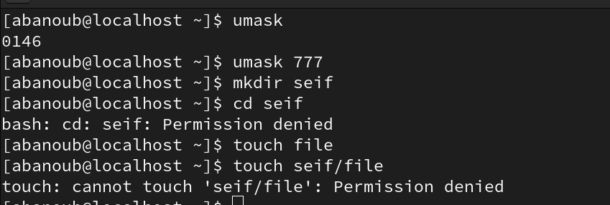

. What are the minimum permission needed for:

• Copy a directory (source directory: r, target parent directory: w)

• Copy a file (source file: r, target parent directory: w)

• Delete a file (file: w, target parent directory: w)

• Change to a directory (directory: x)

• List a directory content (ls command): directory: r

• View a file content (more/cat command): file: r

• Modify a file content: file: w

1. Create a file with permission 444. Try to edit in it and to remove it? Note what happened.

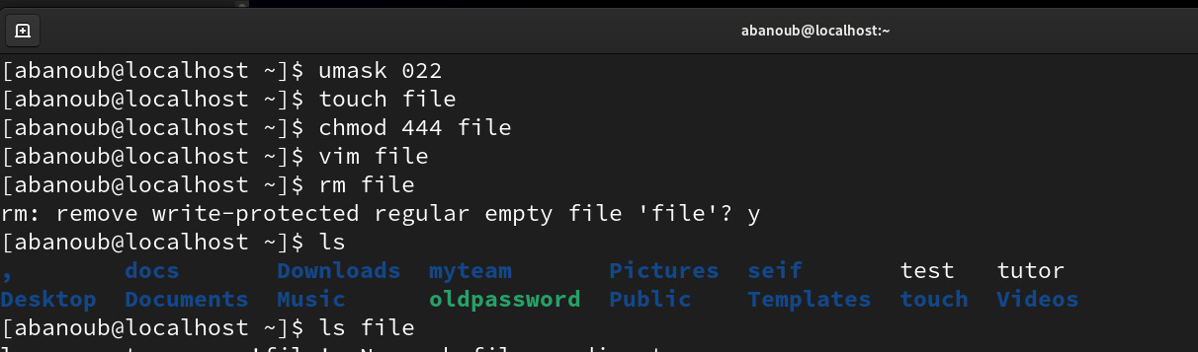

1. What is the difference between the “x” permission for a file and for a directory?

**For a file:**

x permission allows executing the file as a program or script.

**For a directory:**

x permission allows accessing the contents of the directory. Without "x" permission, one cannot enter the directory or access any files or subdirectories within it.